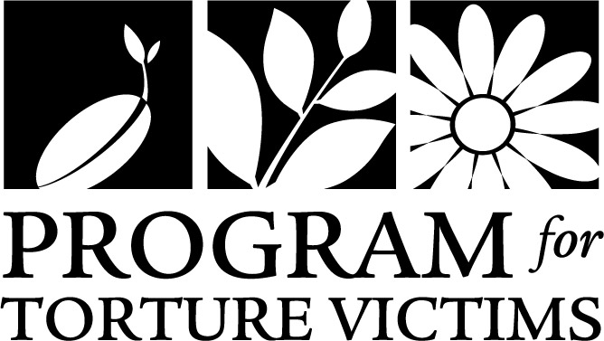

Client Referral Form
To refer a client for services, please submit this completed form, I-589 application and declaration to refer@ptvla.org. You may alternately fax the documents to 213.465.4843, but email is preferred. PTV will review the referral to determine client eligibility for our program. Please note that a referral does not guarantee services. If you have any questions, please email refer@ptvla.org or call 213.384.4788. Thank you!

Is this a LA Justice Fund (LAJF) OR St. John’s referral? YES NO
If this is a LAJF or St. John’s referral, please complete this form and email it directly to PTV’s clinical director, Carol Gomez, at cgomez@ptvla.org
Date Referred: ______________________ Your Name: __________________________
Relationship to Client: Attorney Paralegal Advocate/Social Worker Other: _________________
Address: _________________________________________________________________________________
Phone: ___________________________________ Email Address: ______________________________
Client Name: ______________________________ A #: _________________________________
Address: __________________________________ Phone: _______________________________
Home Country: _____________________________ Interpreter needed: Yes* No
* Please see PTV’s attached interpreter policy
Primary Language: __________________________
Is the client filing for asylum? Yes No If yes, has the I-589 been filed yet? Yes No
Date the client’s I-589 was filed ___/____/_______ Date of Arrival to the US: ___/____/_______
What is the client’s current immigration status? ________________________________________
Scheduled upcoming hearings or interviews: USCIS Affirmative Asylum Application Backlog
USCIS Interview Date: ___/____/_______
Master Calendar Hearing Date: ___/____/_______
Merits Hearing Date: ___/____/_______
Why are you referring your client to PTV? Psychological Evaluation
Medical Evaluation
Supportive services (therapy, medical care, case management)
Special Issues or Notes for PTV Intake Team:

PTV Guidelines for Attorneys:
Forensic Medical or Psychological Evaluations for Asylum Seekers
Revised 11/08/2017
MEDICAL AND PSYCHOLOGICAL EVALUATIONS
- A referral to PTV by an attorney, government entity or nonprofit organization does not guarantee acceptance for services. PTV reserves the right to determine eligibility based on predetermined criteria and/or additional requirements mandated by funders.

- Medical evaluations may require 2 or more sessions with our physicians and Psychological evaluations may require 6 or more sessions at our Los Angeles office. Report writing takes an additional three to four weeks to complete. Please consider this timeline when requesting services from PTV.

- To refer a client, please submit your client’s I-589 application and declaration, and PTV attorney referral form via the contact information on page 2.

- Sometimes, after careful evaluation, we cannot write a favorable report. In these cases, we reserve the right NOT to issue a report.

- We kindly request that attorneys give us ample notice is requiring forensic evaluators to revise drafts of the forensic reports or to serve as an expert witness in court
INTERPRETER SERVICES
Due to a reduction in federal grants, the Program for Torture Victims no longer receives funds to support interpreter services for medical or psychological evaluation in support of asylum cases.
Therefore, beginning March 1, 2013 any new requests for medical and/or psychological evaluations, that require interpreter services, must be accompanied by a one-time interpreter fee of $300.00. This fee covers approximately six sessions with one of our therapists and/or medical director necessary to conduct a forensic report.
- PTV will only accept checks made out to PTV from an attorney account. Please note your client’s last name in the memo section of the check. PTV will not accept any form of payment from clients.
- Payment for the interpreter fee must be received by PTV before a psychological or medical evaluation can be scheduled.
- Interpreter services for psychological therapy or medical treatment after evaluations are completed will continue to be paid for by PTV.
- PTV currently works with a network of professionally trained interpreters to provide a wide variety of languages to meet the needs of clients. Allowing PTV to screen, train and engage our interpreters will ensure high levels of service, professionalism, and availability.

- Attorneys may provide their own interpreters for any client referred to PTV. However, due to the sensitive and confidential nature of client information, PTV must screen and train the interpreter before the client’s first appointment. A training session will be provided by PTV’s Clinical Director before interpreting the first client session. The interpreter may not be a friend or family member of the client. PTV retains the sole right to judge the fitness and qualification of the interpreter. Interpreters provided by attorneys who miss and/or are late for two client appointments will be disqualified.

- Once a medical or psychological evaluation process has begun, the interpreter fee for that evaluation becomes non-refundable. If a client drops out of the evaluation process for longer than 6 months, a new fee will be required.

- For indigent or low-income clients, PTV requests that pro-bono attorneys provide fee payment for interpreter services without passing these expenses on to our mutual client.

Please acknowledge receipt of these guidelines by signing and returning this document and returning it to the Program for Torture Victims via mail, e-mail, or fax (see below).

__________________________________________________________________________________
Date Attorney’s Law Firm

By mail to:
Case Management Team
Program for Torture Victims
3550 Wilshire Blvd, Suite 1906
Los Angeles, CA 90010
By email to:
refer@ptvla.org
By fax to:
Attn: Case Mgt Team
(213) 465-4843

